Call for projects for higher education, research, vocational training and youth institutions
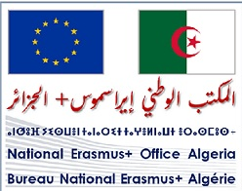

Erasmus+ Opportunities 2026
1. Call for projects for institutions
To mark the launch of the Erasmus+ 2026 call for projects, the Erasmus+ National Office in Algeria invites higher education, research, vocational training and youth institutions to submit their proposals for the following categories:
International mobility projects:
• Academic mobility (ICM), facilitating exchanges of students and academic staff.
• Virtual exchanges, promoting digital collaboration and interactive learning.
• Youth exchanges, aimed at promoting intercultural dialogue and youth engagement.
Cooperation projects:
• Capacity-building projects in the fields of higher education (CBHE), vocational training (CBVET) and youth (CBY), to support institutional and sectoral development.
• Erasmus Mundus courses, including joint master's degrees and design measures, aimed at strengthening academic excellence.
Jean Monnet Activities:
• Modules, Chairs, Centres of Excellence and Networks dedicated to promoting and deepening European studies.
With a budget of €5.2 billion, the Erasmus+ 2026 call for proposals is even more ambitious than its predecessor (the 2025 call). The latter enabled Algerian institutions to secure nearly 300 exchange projects, benefiting hundreds of students, teachers and university staff, as well as six capacity-building projects (CBHE, CBVET and CBY) and two virtual exchange projects.
To facilitate a better understanding of the Erasmus+ 2026 call for proposals, the Erasmus+ National Office in Algeria has made a submission guide and explanatory brochures available to project leaders.

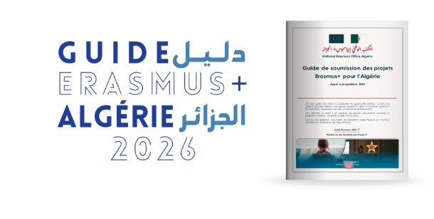


2. Scholarships for students
In Algeria, the Erasmus+ programme offers two types of opportunities for students:
1. ICM Mobility: these scholarships are offered by Algerian higher education institutions that have Erasmus+ partnerships with European universities.
Interested candidates are invited to contact their institution for detailed information on existing Erasmus+ agreements and application procedures.
1. Erasmus Mundus scholarships: these scholarships enable students to pursue a master's degree in Europe. To apply, candidates must hold at least a three-year degree (graduates are also eligible). Applications are made online via the Erasmus Mundus catalogue.

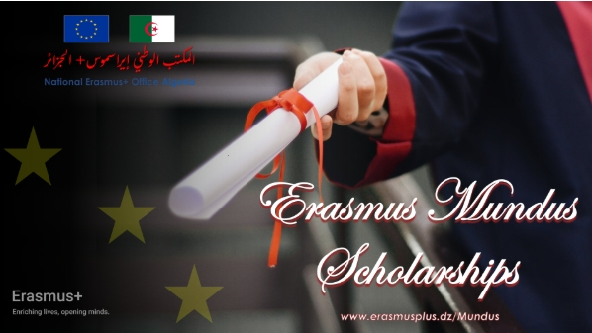


2. Research Scholarships

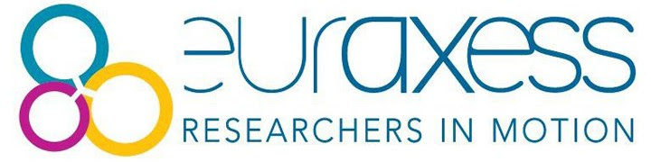

You can apply for study and research opportunities (PhD, postdoctoral, etc.) via the following platforms:
- Euraxess Funding & Jobs
- DAAD Scholarships
- Study in Germany
- COST Actions
- Eurodesk Programmes
- Scientify Research Grants
We have also attached the Erasmus Mundus application guide and various relevant brochures:
- Erasmus Mundus Handbook.pdf
- EU Opportunities.pdf
- Opportunities for individuals.pdf
- International opportunities for youth.pdf
For further information or if you need assistance with your application, the Erasmus+ National Office in Algeria is at your disposal. Please do not hesitate to contact us!



