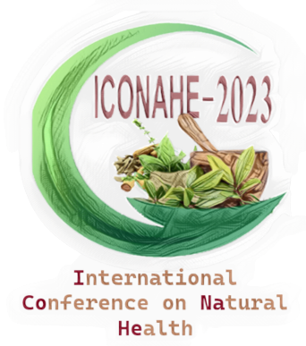

Registration form
3rd International Conference «Natural and Health »
26th-28th November, 2023
3rd ICONAHE

First name |  |  |  | Last name |  |  |  |  | Title
Institution
Address
Postal code |  | City |  |  |  | Country
Email |  |  |  | Phone |  |  | Fax

I wish to give the presentation by: Oral Poster

 | Without  Accomodation |  | With  Accomodation (2 nights)  26-27 Novembre
Academic Scientists – Foreigners | 100 Euros |  | 200 Euros
Academic Scientists – Algerians | 10000.00 DA |  | 20000.00 DA
Algerian Junior Scientists  (PhD students) | 5000.00 DA |  | 15000.00 DA
Accompanying person | 80 Euros |  | 150 Euros

The Registration Fee Covers :
Admission to the Conference, Printed Materials, Coffee Breaks, Lunch and Dinner During November 26-28, Welcome Party ,Gala Dinner

Signature Date: / /2023

