   | Abdelhamid Ibn-Badis University, Mostaganem  Faculty of Exact Sciences and Computer Science  Computer Science & New Technologies Workshop  CSNT’2024  Mostaganem, Algeria, December 8, 2024 | 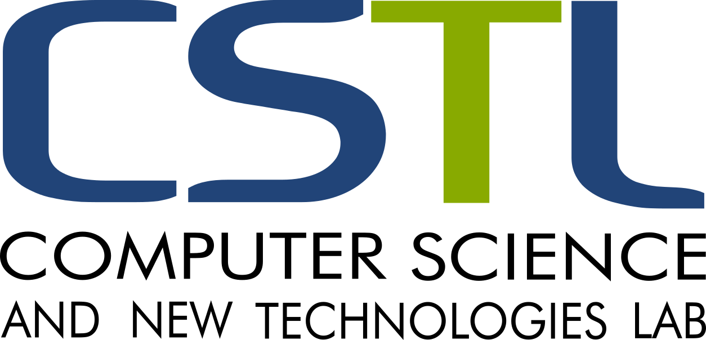
Program
08:00 ∼ 09:00 | Registration
09:00 ∼ 09:30 | Opening Ceremony Auditorium Mordi Senouci  Opening Allocution  Pr. Brahim Boudrah, Rector of Mostaganem University and Honorary Chair of CSNT’2024  Pr. Abdessamad Amir, Dean of the Faculty of Exact Sciences and Computer Science
09:30 ∼ 09:45 | Pr Karim Sehaba  CSNT’2024 presentation
09:45 ∼ 10:45 | Session chairs:  Pr Baghdad Atmani  Pr. Sidi Mohamed Benslimane  Keynote: Pr Lhouari Nourine  Embedding in Continuous Space  Clermont Auvergne University, France
10:45 ∼ 11:15 | Coffee-Break
11:15 ∼ 12:45 | Parallel Sessions
 | Session 1: Auditorium Mordi Senouci  Session chairs:  Pr. Karim Sehaba  Pr. Fatiha Barigou | Session 2: Salle Polyvalente  Session chairs:  Pr. Ghalem Belalem  Dr. Adnane Laredj
 | Sabir Mohammedi  Distributed Algorithm for Choosing a Facilitator within a Group Decision Support System | Wissam Boudjahfa  Enhance containers security using Neural Networks
 | Hammadi Mahmoud  Trends, Innovations, Challenges, and Opportunities in a Data-Driven World | Tehami Amel  Color Image Segmentation Based on Wild Horse Optimization
 | Toufik Achir  Towards identifying multicriteria outliers: An approach based on PROMETHEE γ and DBSCAN algorithm | Hadjer Fatima Rouam Serik  Hybrid approach for task scheduling optimization in cloud computing environments
12:45 ∼ 14:00 | Lunch

14:00 ∼ 15:30 | Parallel Sessions
 | Session 3: Auditorium Mordi Senouci  Session chairs:  Pr Elberrichi Zakaria  Dr. Mohamed Midoun | Session 4: Salle Polyvalente  Session chairs:  Pr Djamel Amar Bensaber  Dr Moulay Driss Mechaoui
 | Hadj Ali Elmerahi  Early Prediction Sepsis Using Parallel Deep Learning: Pre- and Post-Processing of Data from the 2019 PhysioNet/Computing in Cardiology Challenge Dataset | Zeblah Ikhlas  Recommendation Systems in Collaborative Learning Environment: PRISMA
 | Said Ben Amara  Enhancing performance for remote Labs based to RESTful API and MERN stack technologies | Kaouther Soltani  Adaptive dashboards for computer-supported collaborative learning: A systematic literature review using PRISMA
 | Amina Fatima Zohra Medjahed  Data Synergy in Healthcare: Exploring Approaches to Medical Data Integration | Houcine Ourabah  Investigating Gaps in Blockchain Scalability and Conflict Resolution: The Potential of CRDTs and AI in Decentralized Environments
15:30 ∼ 15:45 | Coffee-Break
15:45 ∼ 17:00 | Auditorium Mordi Senouci  Session chairs:  Pr. Baghdad Atmani  Pr. Karim Sehaba  Debate

