**Département de Langue Espagnole**

**Planning des Examens Semestre II (2021-2022)**

**Vague II –L/2 & M/1**

**Du 12-06-2022 Au 15-06-2022**

|  |  |  |  |  |  |  |
| --- | --- | --- | --- | --- | --- | --- |
| **Date** | **Heure** | **Spé/Niv** | **Matière** | **Resp.** | **GRP** | **Salle** |
| **Dimanche**  **12/06/2022** | **08H30-09H30** | **L2** | **Ling.** | Derdachi | **1** | 63 |
| **2** | 64 |
| **3** | 65 |
| SL | Socioling. | Hammal | | 66 |
| LC | AD | Meknassi | | 67 |
| Did | Did. Oral | Morceli | | 31 |
| Civ | Traduction | Djebaili | | 32 |
| **10H00-11H00** | **L2** | **Gram.** | Meknassi  Benmahiedin | **1** | 63 |
| **2** | 64 |
| **3** | 65 |
| SL | Sémantique | Meknassi | | 66 |
| LC | P.C.O | Morceli | | 67 |
| Did | Prag.Com. | Bouzid | | 31 |
| Civ | Hist. Esp. Mus | Fékih | | 32 |
| **11H30-12H30** | **L2** | **Anglais** | Choukari | **1** | 63 |
| **2** | 64 |
| **3** | 65 |
| SL | LS | Bouzid | | 66 |
| LC | Ethique | Houcine | | 67 |
| Did | Ling. App. | Loualiche | | 31 |
| Civ | ///// | ////// | | 32 |

|  |  |  |  |  |  |  |
| --- | --- | --- | --- | --- | --- | --- |
| **Date** | **Heure** | **Niv/Spec.** | **Matière** | **Resp.** | **GRP** | **Salle** |
| **Lundi**  **13/06/2022** | **08H30-09H30** | **L2** | **Civ.** | Bessioud | **1** | 63 |
| **2** | 64 |
| **3** | 65 |
| SL | Pragmatique | Yahia | | 66 |
| LC | Prat.Com. ect | Dria | | 67 |
| Did | Did.Txt. Lit. | Mortet | | 31 |
| Civ | Prat. Com. | Messaoud | | 32 |
| **10H00-11H00** | **L2** | **Phonet.** | Belhadj | **1** | 63 |
| **2** | 64 |
| **3** | 65 |
| SL | Met. Ensg. | Dria | | 66 |
| LC | Management | Zeggane | | 67 |
| Did | Prat. Com. | Kellal | | 31 |
| Civ | Hist. Mors. Mu | Markria | | 32 |
| **11H30-12H30** | **L2** | **Traduction** | Djebaili | **1** | 63 |
| **2** | 64 |
| **3** | 65 |
| SL | Prat. Com. | Yahia | | 66 |
| LC | LS | Belhadj | | 67 |
| Did | AOD | Guellailia | | 31 |
| Civ | Tec. Red. | Markria | | 32 |

|  |  |  |  |  |  |  |
| --- | --- | --- | --- | --- | --- | --- |
| **Date** | **Heure** | **Spé/Niv** | **Matière** | **Resp.** | **GRP** | **Salle** |
| **Mardi**  **14/06/2022** | **08H30-09H30** | **L2** | **CEE.** | Sahbatou  Kellal | **1** | 63 |
| **2** | 64 |
| **3** | 65 |
| SL | Hist. Lang | Kouadri | | 66 |
| LC | Metod. proj | Zahaf | | 67 |
| Did | Evaluation | Bouzid | | 31 |
| Civ | Lit. esp. Mus | Khordj | | 32 |
| **10H00-11H00** | **L2** | Litt. | Benaouda | **1** | 63 |
| **2** | 64 |
| **3** | 65 |
| SL | Metodo | Bouzid | | 66 |
| LC | Metod. Rech | Zahaf | | 67 |
| Did | Cult. Intercul | Bouzid | | 31 |
| Civ | AD | Khordj | | 32 |
| **11H30-12H30** | **L2** | **TICE** | Henni | **1** | 63 |
| **2** | 64 |
| **3** | 65 |
| SL | Traduction | Djebaili | | 66 |
| LC | Code Edit. | Houcine | | 67 |
| Did | Metod. Rech | Bouzid | | 31 |
| Civ | Soc.Esp. | Sahbatou | | 32 |

|  |  |  |  |  |  |  |
| --- | --- | --- | --- | --- | --- | --- |
| **Date** | **Heure** | **Spé/Niv** | **Matière** | **Resp.** | **GRP** | **Salle** |
| **Mercredi**  **15/06/2022** | **08H30-09H30** | **L2** | **CEO** | Bessioud | **A** | 63 |
| Derkaoui  Hadjoudja | **B** | 64 |
| SL | Anglais | Khinèche | | 66 |
| LC | //// | ///// | | 67 |
| Did | Did. ecrit | Ouali | | 31 |
| Civ | Metod. Rech | Malki | | 32 |
| **10H00-11H00** | SL | ///// | ///// | | 66 |
| LC | ///// | ////// | | 67 |
| Did | ////// | ///// | | 31 |
| Civ | Lit.Mors. Mu | Malki | | 32 |

**Le chef du départem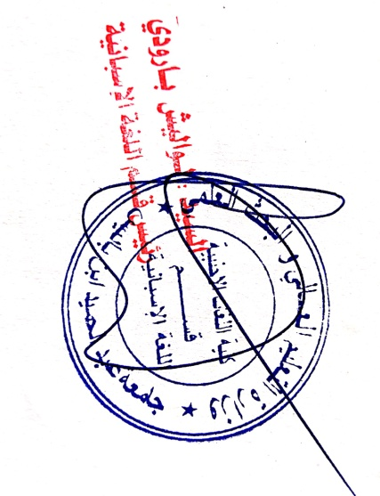ent**