 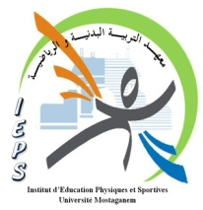

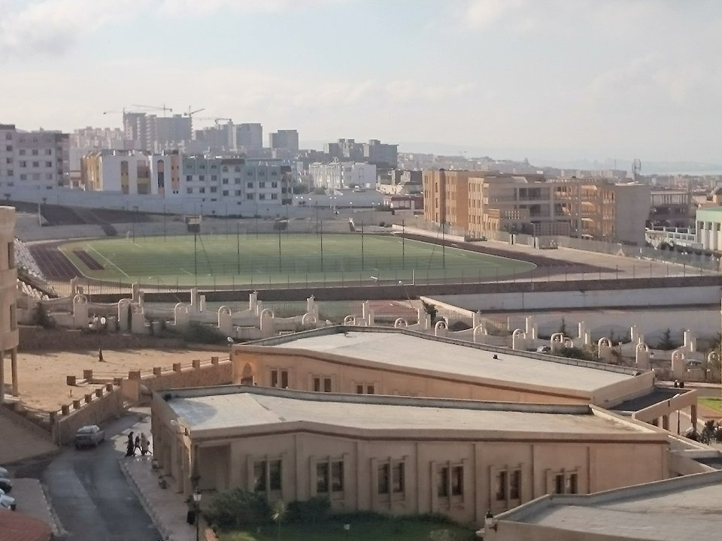

**The problematic of the conference**

**The status of science and techniques of physical activities**

**And sports in the community**

**Future challenges**

**Nowadays the physical exercise and sports activities are considered vital to man’s life as it represents a great significance in his daily life as an individual in society , furthermore many studies and researches have proven the importance of sport on our health, and all our life aspects, psychological , social and economic …etc**

**There is no doubt that the good practice of physical and sports activities in a scientific ways contributes greatly to the attainment of the established goals and to contribute to long-term human investment that serves the goals set for the comprehensive system of society. This relationship between the different components is a necessary condition for success drawn to society.**

**Today, thinking has been focused on rearranging, reordering and adapting the rules in line with new trends that serve the aspired development. It is therefore necessary to think of a new perspective and an oriental vision in line with these new trends.**

**Therefore, this conference addresses the topic :**

**The status of science and techniques of physical activities**

**and sports in the society.**

**Future challenges**

**Hoping to consummate achieving a concession of achievements hence:**

**1. Analyzing the reality of training in the sciences of physical and sports activities in a way that serves the general trends.**

**2. Linking the objectives of training in the social field through the opinions of researchers, experts and specialists.**

**3. Adapting science and technology to physical and sports activities to match and contribute to economic reality.**

**4. Convoking experts and scientists to predict what serves the future challenges of physical and sporting activities.**

**Conference Themes:**

**A - Structure and implications of the sciences and techniques of physical and sports activities on the individual and the society which incorporates:**

**1 - Coaching educational physical activity and its entrancement of the individual as well as the society**

**2 - Coaching athletic training and its entrancement of the individual as well as the society**

**3 - Coaching adapted physical activity and its entrancement of the individual as well as the society.**

**4 - Coaching in the media and sports communication and its entrancement of the individual as well as the society.**

**5 - Training in the field of sports marketing and sports tourism and its impact on the national economy.**

**B – The arena of science and technology of physical activities, sports and economic revenue and it includes:**

**1 - Educational physical athletic sports and its economic revenue.**

**2- Athletic coaching and its economic revenue.**

**3. Adaptive physical activity and economic revenue.**

**4- Media and sports communication and economic revenue.**

**5- Sports marketing, sports tourism and economic revenue.**

**C. The implications of technological and social media on the field of science and technology of physical and sports activities, including:**

**1. Use and employment of technology in the field of science and technology of physical and sports activities.**

**2 - Sports media as a means to serve the field of science and technology of physical and sports activities.**

**3. Utilization of technological and information media in the field of science and technology for physical and sports activities.**

**Future vision in the field of science and technology of physical and sports activities.**

**1. Leading global experiences in the field of science and technology for physical and sports activities.**

**2 - Future solutions to raise the challenge in the sciences and techniques of physical and sports activities.**