


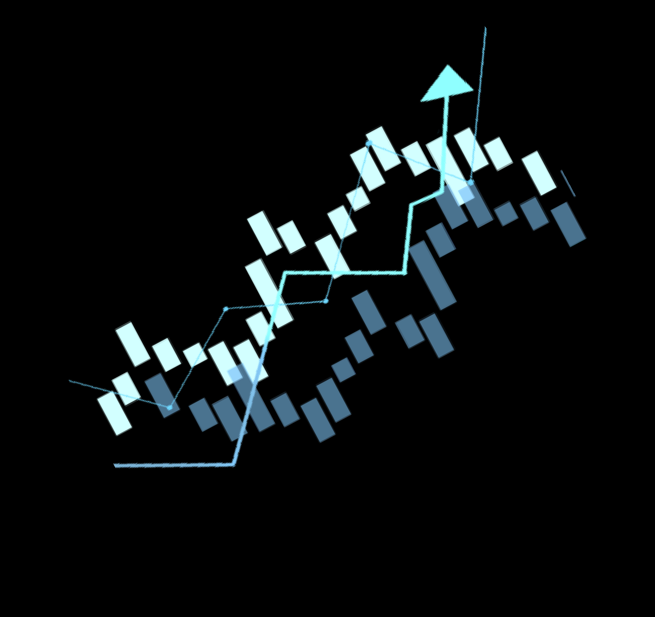
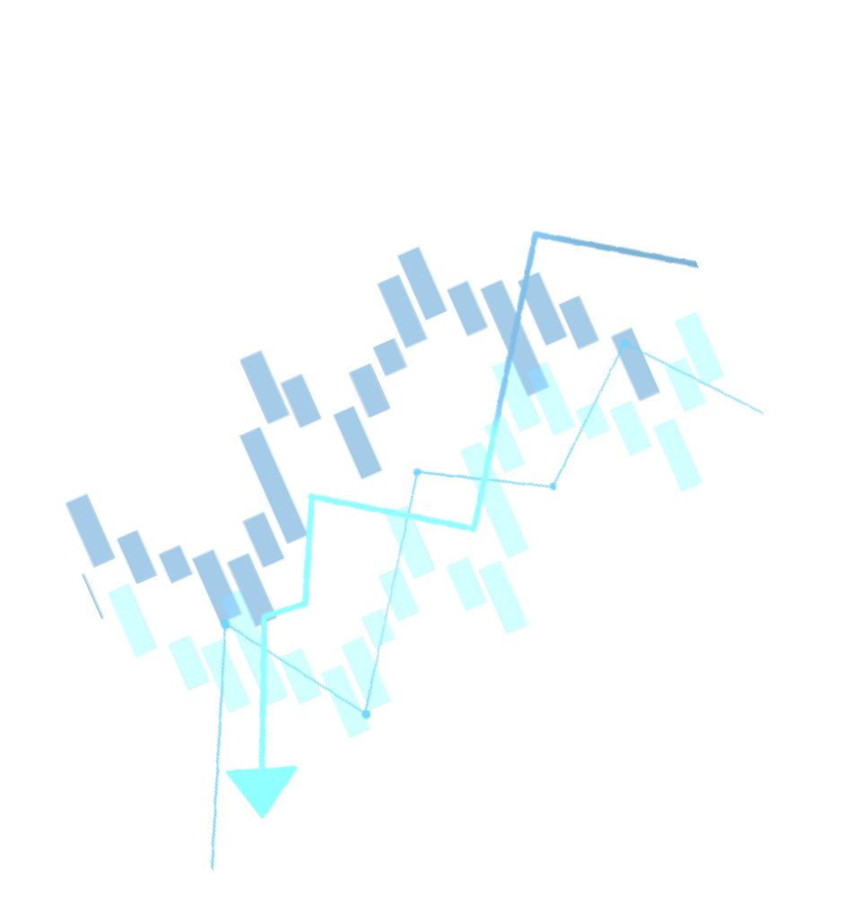
















Laboratory Optimization of Sports Activity Programs LABOPAPS (CODE W0890400)

Photo | الاسم:  اللقب:  الدرجة العلمية:  التخصص:  مؤسسة الانتماء:


05

.....................................................................................................................................................................................................................................................

.....................................................................................................................................................................................................................................................

.....................................................................................................................................................................................................................................................

.....................................................................................................................................................................................................................................................

.....................................................................................................................................................................................................................................................

.....................................................................................................................................................................................................................................................

.....................................................................................................................................................................................................................................................

.....................................................................................................................................................................................................................................................

.....................................................................................................................................................................................................................................................

.....................................................................................................................................................................................................................................................

.....................................................................................................................................................................................................................................................


..........................................................................................................................................

..........................................................................................................................................

..........................................................................................................................................

..........................................................................................................................................

..........................................................................................................................................

